Create a React Application named “cricketapp” with the following components:

1. ListofPlayers

* Declare an array with 11 players and store details of their names and scores using the map feature of ES6
* Filter the players with scores below 70 using arrow functions of ES6.

1. IndianPlayers
   1. Display the Odd Team Player and Even Team players using the Destructuring features of ES6
   2. Declare two arrays T20players and RanjiTrophy players and merge the two arrays and display them using the Merge feature of ES6

CODE:

ListofPlayers.js

import React from 'react';

const ListofPlayers = () => {

  const players = [

    { name: 'Virat Kohli', score: 120 },

    { name: 'Rohit Sharma', score: 85 },

    { name: 'KL Rahul', score: 65 },

    { name: 'Shikhar Dhawan', score: 90 },

    { name: 'MS Dhoni', score: 55 },

    { name: 'Rishabh Pant', score: 70 },

    { name: 'Hardik Pandya', score: 45 },

    { name: 'Ravindra Jadeja', score: 60 },

    { name: 'Jasprit Bumrah', score: 20 },

    { name: 'Mohammed Shami', score: 15 },

    { name: 'Yuzvendra Chahal', score: 30 },

  ];

  const lowScorers = players.filter(player => player.score < 70);

  return (

    <div>

      <h2>All Players</h2>

      <ul>

        {players.map((player, index) => (

          <li key={index}>

            {player.name}: {player.score}

          </li>

        ))}

      </ul>

      <h2>Players with Scores Below 70</h2>

      <ul>

        {lowScorers.map((player, index) => (

          <li key={index}>

            {player.name}: {player.score}

          </li>

        ))}

      </ul>

    </div>

  );

};

export default ListofPlayers;

IndianPlayers.js

import React from 'react';

const IndianPlayers = () => {

  const players = [

    'Virat Kohli',

    'Rohit Sharma',

    'KL Rahul',

    'Shikhar Dhawan',

    'MS Dhoni',

    'Rishabh Pant',

    'Hardik Pandya',

    'Ravindra Jadeja',

    'Jasprit Bumrah',

    'Mohammed Shami',

    'Yuzvendra Chahal',

  ];

  const [oddPlayers, evenPlayers] = [

    players.filter((_, index) => index % 2 === 0),

    players.filter((_, index) => index % 2 !== 0),

  ];

  return (

    <div>

      <h2>Odd Team Players</h2>

      <ul>

        {oddPlayers.map((player, index) => (

          <li key={index}>{player}</li>

        ))}

      </ul>

      <h2>Even Team Players</h2>

      <ul>

        {evenPlayers.map((player, index) => (

          <li key={index}>{player}</li>

        ))}

      </ul>

    </div>

  );

};

export default IndianPlayers;

App.js

import React, { useState } from 'react';

import ListofPlayers from './components/ListofPlayers';

import IndianPlayers from './components/IndianPlayers';

import './App.css';

function App() {

  const [flag, setFlag] = useState(true);

  const T20players = ['Virat Kohli', 'Rohit Sharma', 'KL Rahul'];

  const RanjiTrophyPlayers = ['Ajinkya Rahane', 'Cheteshwar Pujara', 'Hanuma Vihari'];

  const mergedPlayers = [...T20players, ...RanjiTrophyPlayers];

  return (

    <div className="App">

      <h1>Cricket App</h1>

      <button onClick={() => setFlag(!flag)}>

        Toggle View (Flag: {flag.toString()})

      </button>

      {flag ? (

        <ListofPlayers />

      ) : (

        <IndianPlayers />

      )}

      <h2>Merged Players (T20 + Ranji)</h2>

      <ul>

        {mergedPlayers.map((player, index) => (

          <li key={index}>{player}</li>

        ))}

      </ul>

    </div>

  );

}

export default App;

OUTPUT:

When Flag = true

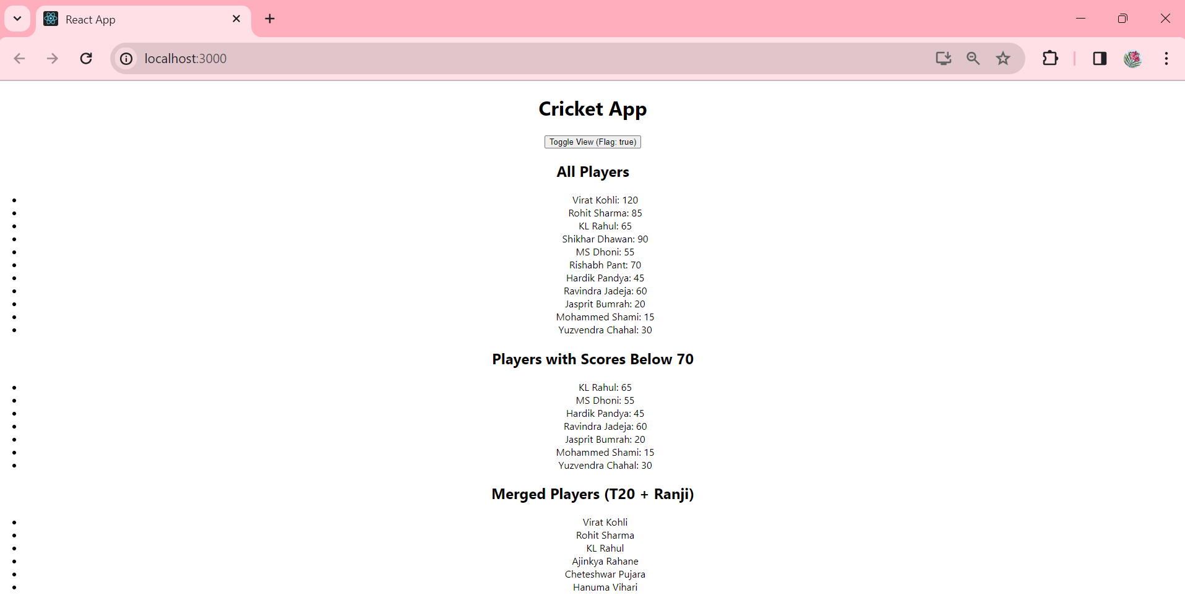

When Flag = false

